DSP EXPERIMENTS
NAME:N.ALGIPRAN
COURSE NAME & CODE:ECA0901-DIGITAL SIGNAL PROCESSING

4..1. Design and Analysis of an FIR Low-Pass Filter Using the Rectangular Window
Technique in MATLAB

CODE:

clc;
clear;
close all;
%% --- Input Parameters ---
fp = 1000; % Passband cutoff (Hz)
fs = 4000; % Sampling frequency (Hz)
N = 50; % Filter order (even number preferred)

wc = fp/(fs/2); % Normalized cutoff frequency (0 to 1)
%% --- 1. FIR Low Pass using Rectangular Window ---
b_rect = fir1(N, wc, 'low', rectwin(N+1));
disp('--- Rectangular Window Coefficients ---');
disp(b_rect');
%% --- 2. FIR Low Pass using Hamming Window ---
b_hamm = fir1(N, wc, 'low', hamming(N+1));
disp('--- Hamming Window Coefficients ---');
disp(b_hamm');
%% --- 3. FIR Low Pass using Hanning Window ---
b_hann = fir1(N, wc, 'low', hanning(N+1));
disp('--- Hanning Window Coefficients ---');
disp(b_hann');
%% --- Plot Frequency Responses ---
figure;
freqz(b_rect,1);
title('Low-pass FIR using Rectangular Window');
figure;
freqz(b_hamm,1);
title('Low-pass FIR using Hamming Window');
figure;
freqz(b_hann,1);
title('Low-pass FIR using Hanning Window');
OUTPUT:

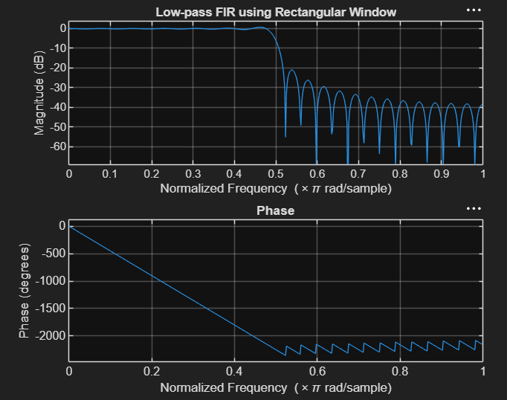

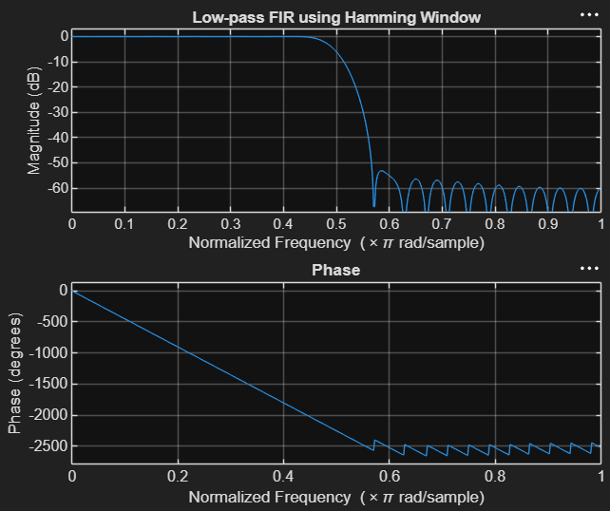

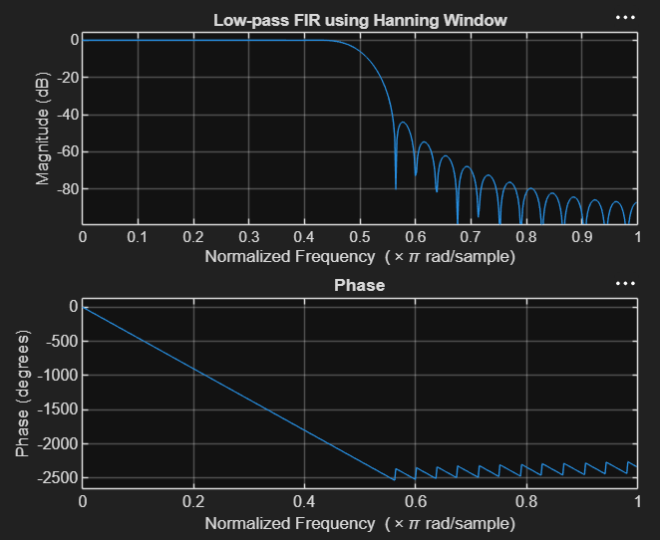

4.2. Design and Analysis of an FIR Low-Pass Filter Using the Hamming Window
Technique in MATLAB

CODE:

clc;
clear;
close all;
%% --- Input Parameters ---
fp = 1000; % Passband cutoff (Hz)
fs = 4000; % Sampling frequency (Hz)
N = 50; % Filter order (even number preferred)
wc = fp/(fs/2); % Normalized cutoff frequency (0 to 1)
%% --- FIR Low Pass using Hamming Window ---

b_hamm = fir1(N, wc, 'low', hamming(N+1));
disp('--- Hamming Window Coefficients ---');
disp(b_hamm');
%% --- Plot Frequency Responses ---
figure;
freqz(b_hamm,1);
title('Low-pass FIR using Hamming Window');

OUTPUT:

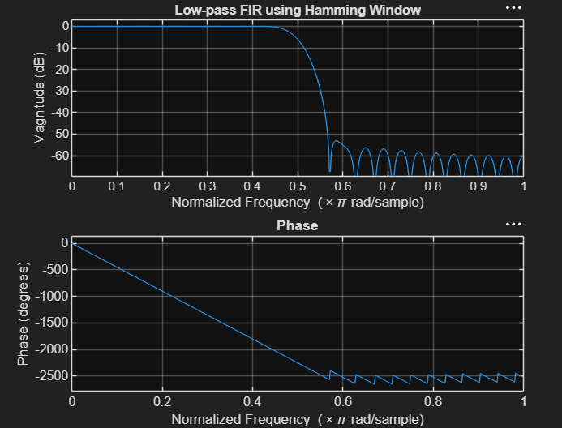

4.3. Design and Analysis of an FIR Low-Pass Filter Using the Hanning Window
Technique in MATLAB

CODE:
clc;
clear;
close all;
%% --- Input Parameters ---
fp = 1000; % Passband cutoff (Hz)
fs = 4000; % Sampling frequency (Hz)
N = 50; % Filter order (even number preferred)
wc = fp/(fs/2); % Normalized cutoff frequency (0 to 1)

%% --- FIR Low Pass using Hanning Window ---
b_hann = fir1(N, wc, 'low', hanning(N+1));
disp('--- Hanning Window Coefficients ---');
disp(b_hann');
%% --- Plot Frequency Responses ---
figure;
freqz(b_hann,1);
title('Low-pass FIR using Hanning Window');
OUTPUT:

